**THE MEN OF SMITH & THE WOMEN OF SMITH**

The Men and Women of Smith are, first and foremost, service organizations. Our projects include hosting a college bound workshop and an annual high school leadership workshop. We have drives to collect canned goods, clothes and personal items. These drives aid victims of natural disasters, local food banks and our own “Golden Closet”. The organizations help to beautify our campus and promote school spirit. We host two blood drives each year and assist in feeding the homeless. Our members enjoy mentoring younger students and spearheading the Smith Spring Festival. The purpose of these organizations is to enhance the character, integrity, commitment, scholarship and leadership skills of these outstanding young ladies and young gentlemen. A principle focus is for us to lead by example.

Criteria for becoming a member of the Women of Smith and the Men of Smith are:

* **Good grades—at least a 2.0 grade point average**
* **Good references and reports from your teachers**
* **No excessive suspensions, absences, tardies or behavior issues**

Once we have evaluated your application, we will be back in touch with you to let you know our final decision of membership.

\***Step team members will have to audition and be members in good standing in the Men of Smith and the Women of Smith**.

MEN OF SMITH

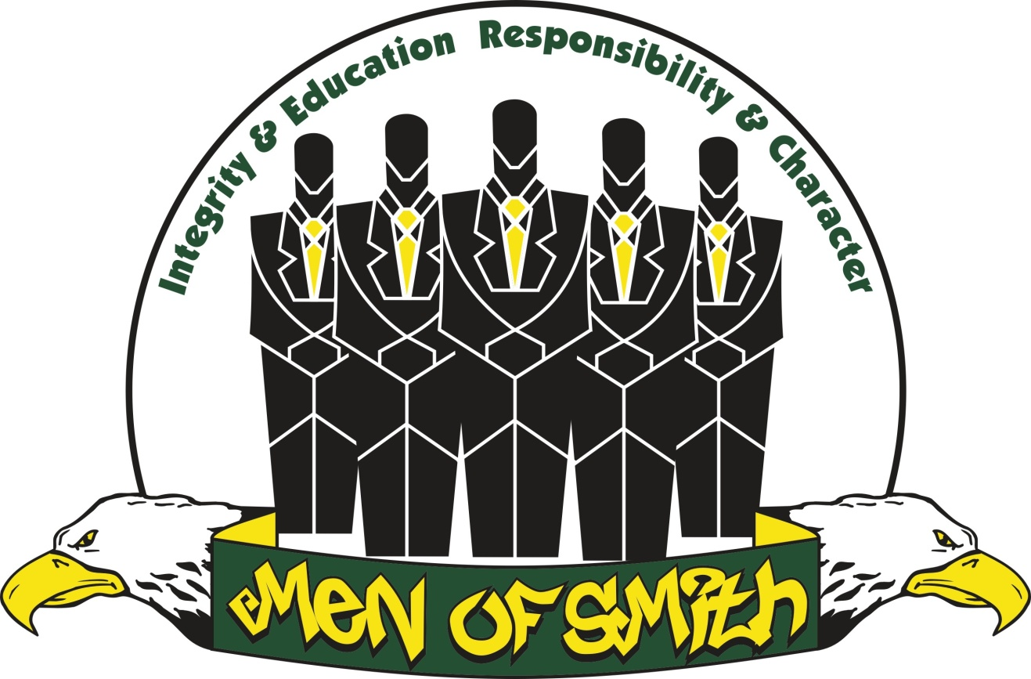

Mission Statement

The Men of Smith is a brotherhood of young men that promotes the social, intellectual, and moral growth of not only its members, but also all young men of Ben L. Smith High School.  Through our actions and service, we support the aims and purpose of our school and community.

WOMEN OF SMITH

Fostering Personal Strength,

Esteem, Integrity and Scholarship

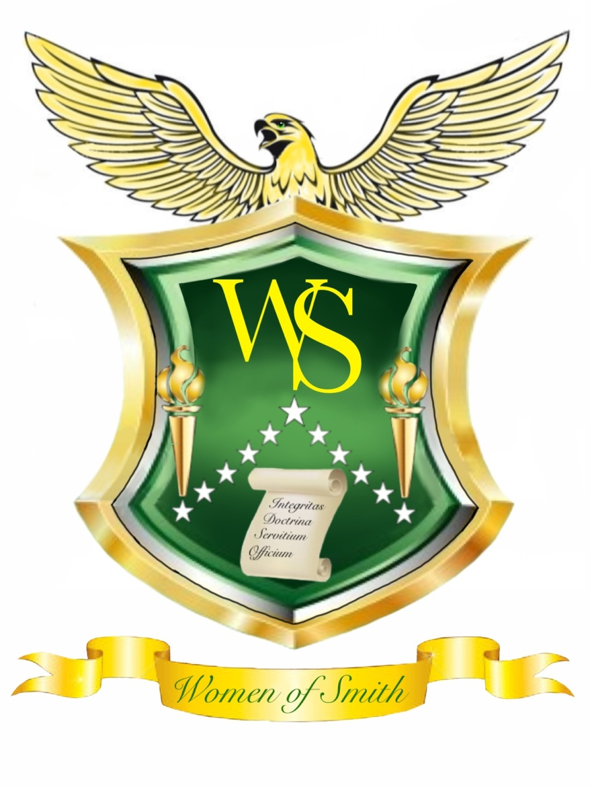

Mission Statement

The Women of Smith is a school-based organization that promotes the social, emotional, and academic growth of female students attending Ben L. Smith High School.

Workshops and other educational activities that address issues specific to female youth are provided to endorse professionalism, leadership, volunteerism, and self- respect.